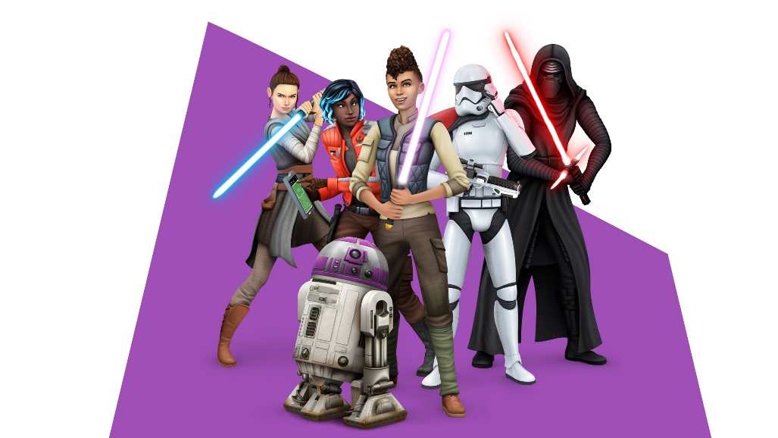

# The Sims™ 4

# STAR WARSTM: JOURNEY TO BATUU.

Browse this pack’s content and get inspired by more fashion, furniture, hairstyles, and décor. Imagine what you’ll make next!

## Create your Star Wars Story

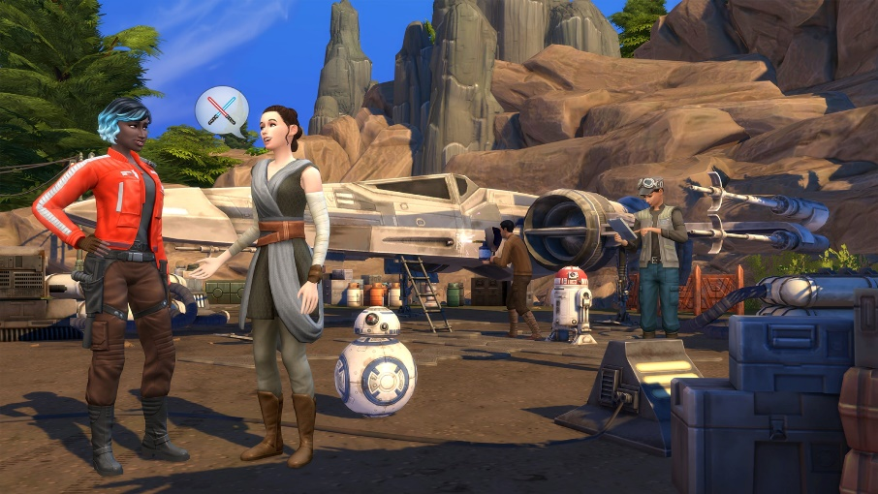

The Resistance, First Order, and scoundrels are fighting to control Batuu, but your Sims' actions determine who will succeed. As Sims undertake challenges and special missions, you’ll tip the balance of power. Your influence not only changes the world, but also unlocks rewards like starfighter access, new outfits, and critical missions on Batuu. And who knows? Maybe you’ll find your B, special someone!